Walk 44 Hoarwithy and Carey
Last walked in December 2016

Description. An excellent 7 km (4.3 miles) easy walk along well defined tracks and along the river Wye.
Start. Lay-by just east of Hoarwithy Bridge. Explorer Map 189 Grid 530509.
Directions from Belmont Roundabout (Turn milometer to zero). Take the A49 to Ross-on-Wye, after 500yds TL at traffic lights towards Holme Lacy on the B4399. After another 500 metres you TR at a mini roundabout and head for Hoarwithy. When you get to the outskirts of Hoarwithy, after 7.1 miles, TL to Kings Caple. Cross over Hoarwithy Bridge and park on the R. Total distance 7.4 miles.

1. Hoarwithy. Hoarwithy is a small village on the River Wye in Herefordshire, It is known for its church of St Catherine's built in an Italian Romanesque style with detached campanile. The church, on a steep hillside above the village was built to a design by J P Seddon by William Poole, the wealthy Vicar of Hentland in the 1870s. Walk west, back over Hoarwithy Bridge and past the Old Toll House on the L. Continue along to the T junction, ignoring the road on the R to Carey, and reach the Hoarwithy sign on the L, (at this point you can always visit St Catherine's church opposite). 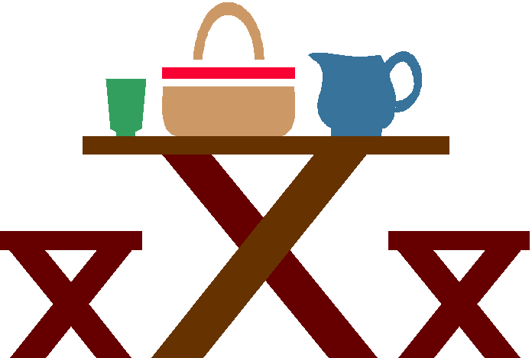 TR up hill towards Little Dewchurch and Hereford and climb for about 200m to the end of the speed restriction. TR just passed the pink house on your R and continue along an unsigned enclosed green lane to reach a tarmac road, ‘Cleveland’ house is on the R. TL and after a short distance uphill, past ‘Stoney-ways’ house you reach a stony bridle path to your R.

2. Bridle Path. TR and follow the enclosed bridle path for about a kilometer, ascending very gradually and pause intermittently for views to the receding river valley below to your R. The path emerges onto a road linking Little Dewchurch to Carey. TR and follow the quiet road down to the bottom where you TL at the T Junction. Pause in front of the Cottage of Content pub and sit by the two public benches over the little bridge and stream.

3. Cottage of Content. Originally The Cottage of Content was built in 1485 as three labourers’ cottages for the Mynor family. This was on the condition that one of the tenants kept an ale & cider parlour in one room, so the 'Cottage' has been a licensed house for quite some time. Resume along the road as it bends R to Ballingham, Holme Lacy and Hereford, the Cottage of Content is on your L, and gently walk uphill, passing ‘The Gaer House’ on your R. Ignore the road to your L to Bolstone and continue straight on and over the bridge of the dismantled railway line, (look L over the parapet for the railway station, now converted to domestic use). Continue along the road for 150m to the public footpath sign on the R.

4. Telegraph Pole. TR at the public footpath sign which is next to a telegraph pole, cross over the stile/metal gate and follow the enclosed green lane gently down hill to reach a wooden gate at the bottom. TR, (don’t go thru the gate) and after a few metres you cross over a stile into field 1 {F1}. Cross this field and head for the five pillars of the old railway viaduct that are in the river. On reaching the river you TR, and cross a stile at Harrison Wye Fishing Club into {F2}, and continue along the bank of the river. Cross a stile/gate into {F3}. Cross a stile/gate into {F4}. Cross a wooden bridge that bears a hopefully unnecessary disclaimer, (Walkers use this bridge at their own risk) and then a stile into {F5}. Continue along the riverbank and cross over two more stiles into {F6}{F7}, then go thru a metal kissing gate into {F8}. Continue straight on, keeping to the river on your L. At the end of this field you cross a stile/metal onto the main road.
3
4
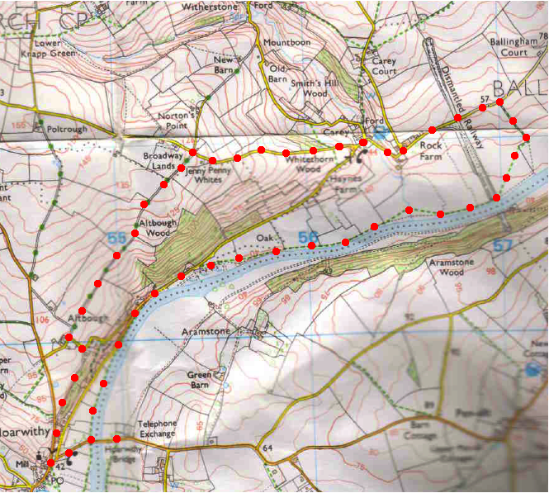

5. Brae Cottage. TL and follow a not unpleasant road for about ½ km, passing Brae Cottage (R), a 30 mph speed restriction sign on your L, and just opposite Wye View House you TL by a public footpath sign and cross over a stile. A few paces further on you TR and go thru a kissing gate into {F9}. Follow the riverbank. Go thru a couple more kissing gates, across a wooden footbridge enclosed by metal gates, and climb some concrete steps to cross over a stile onto the main road where you TL, cross over Hoarwithy Bridge and back to the car.
1
2
5

